Private Company can call Annual General Meeting (AGM) anywhere in the world
The incorporation is the birth of the Company and thereafter the Company comes into existence. As soon as the Company is registered under the Companies Act, the provisions of Companies Act, 1956 is applicable on that Company. There are a lot of Sections under the Companies Act, 1956 which touch the Company but I am here to discuss only sub section (2) of Section 166 of the Companies Act, 1956.
There are Two the most important meeting of a Public Company, First is Statutory Meeting which is hold once in a life of Public Company according to the Section 165 of the Companies Act, 1956 and Other one is Annual General meeting which is hold every year.
In case of Private Company, there is one meeting which is the most important meeting hold every year that is Annual General Meeting. The Annual General Meeting is prescribed under section 166 of the Companies Act, 1956, In this section there is two part
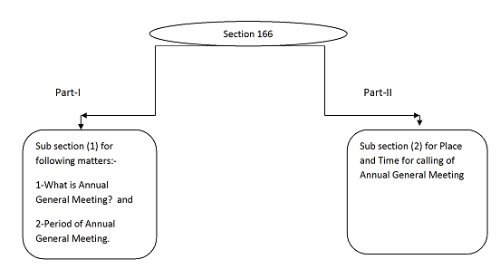
The sub section (2) of Section 166 of the Companies act 1956, which is as below:-
(2) Every annual general meeting shall be called for a time during business hours, on a day that is not a public holiday, and shall be held either at the registered office of the company or at some other place within the city, town or village in which the registered office of the company is situate :
Provided that the Central Government may exempt any class of companies from the provisions of this sub-section subject to such conditions as it may impose:
Provided further that –
(a) a public company or a private company which is a subsidiary of a public company, may by its articles fix the time for its annual general meetings and may also by a resolution passed in one annual general meeting fix the time for its subsequent annual general meetings; and
(b) a private company which is not a subsidiary of a public company, may in like manner and also a resolution agreed to by all the members thereof, fix the times as well as the place for its annual general meeting.
In the view of above paragraphs, I have a Company that is ZXY Private Limited and its registered office is in Delhi and corporate office in Mumbai, Mr. Z, Mr. X and Mr. Y is residing in Mumbai. These three Directors are also Member of Company and are holding 100% shares of ZXY Private Limited.
These three Directors is not showing their interested to conduct Annual General Meeting in Delhi because a lot of hurdle comes in front of them every year and put their interest to conduct Annual General Meeting in Mumbai.
“Can ZXY Private Limited call Annual General Meeting in Mumbai?”
Apparently, it is not possible to call Annual General Meeting in Mumbai where the registered office of the Company is situated in Delhi but it is possible when we will comply with the proviso of Sub Section (2) of Section 166 of the Companies Act, 1956.
Now, when I prepare the Notice of Annual General Meeting, the following important facts I will consider for conducting Annual General Meeting in Mumbai.
Time and Place
The time is so important and it should be during the business hours. The day is not a public holiday. Therefore, I check these basic conditions and come on the following language regarding place of Annual General Meeting which is mentioned in Section 166 (2) of the Companies Act, 1956.
The annual General meeting “shall be held either at the registered office of the company or at some other place within the city, town or village in which the registered office of the company is situate”
That means the meeting should be either on Registered Office of the Company or within the City, Town or Village.
The Registered Office of ZXY Private Limited is in Delhi and it cannot be conducted Annual General Meeting in Mumbai But it is possible to call Annual General Meeting in Mumbai according to the Section 166 of the Companies Act, 1956.
Further, I have focused on two important Provisos:-
First Proviso, it is the power of the Central Government to exempt any class of company as the Central Government may deemed fit with such condition.
Second Proviso:-
It is important for me so I studied very carefully and there is following crush of this proviso:-
In Clause (a) of Second Proviso of sub section (2) of Section 166 of the Companies Act, 1956
Applicability:-
This is applicable for Public Company and private company which is subsidiary of Public Company.
Fixation of Time:-
For fixation of time for subsequent Annual General Meeting, I alter the Article of Association of the Company accordingly and I pass the unanimously resolution in Annual General Meeting in this regard.
But my company is Private Company so this clause is not applicable on my Company.
In Clause (b) of Second Proviso of sub section (2) of Section 166 of the Companies Act, 1956
Applicability:-
This is applicable for Private Company which is not a subsidiary of Public Company.
Fixation of Time and Place:-
For fixation of time and place for subsequent Annual General Meeting, I alter the Article of Association of the company accordingly and I pass the unanimously resolution in Annual General Meeting in this regard
My company is a Private Limited Company and above clause (b) is applicable on ZXY Private Limited,
Now on this basis above clause, I have already altered the Article of Association of the Company and passed unanimously resolution in Last Annual General Meeting.
Therefore, I can call meeting in Mumbai also.
Conclusion
According to above discussion Private Limited Company can call Annual General Meeting in any place in the world if we satisfied both the conditions which is mentioned in the second proviso of Section 166 (2) of the Companies Act, 1956.
Akhilesh Kumar Jha
(Company Secretary and LLB)
Mobile No. 9718403891

