Department of Trade and Taxes

Government of NCT of Delhi

Form BU 02

[See notification under section 16(12)]

(PART-A)

Intimation of withdrawal from Composition Scheme as notified exclusively for bullion traders by Government under sub-section (12) of section 16

Ward No.

1. TIN

- Full Name of Applicant Dealer

- Full Address of Dealer

4. Date with effect from which –

  - withdrawal from composition scheme is sought or

  - ceased to be a composition dealer on account of non-filing of returns for two consecutive return tax periods

- Please tick the appropriate option.

5. | Turnover in the preceding year | (Rs.)
6. | Reasons for withdrawal from composition scheme
7. | Input tax on opening stock | Description* |  |  |  |  |  |  |  | Input tax (Rs.)
 | held in Delhi on the date
 | held in Delhi on the date | (i) Trading Stock
 | mentioned in field no. 4
 | mentioned in field no. 4 | (ii) Packaging Material
 | above
 |  |  |  | Total
 | (* Please complete Part B)
 |  | Name and signature of applicant / authorized signatory

8. Verification

I/We ______________________________________________ hereby solemnly affirm and declare that the information given hereinabove is true and correct to the best of my/our knowledge and belief and nothing has been concealed therefrom.

Signature of Authorised Signatory | ____________________________________
Full Name (first name, middle, surname) | ____________________________________
Designation | ____________________________________

Place

Date

Day | Month | Year

Department of Trade and Taxes

Government of NCT of Delhi

Form BU 02

[See notification under section 16(12)]

(PART B)

Details of opening stock held on the date (i.e. __________________) from which the composition is withdrawn

(i) Details of trading stock on which credit has been sought
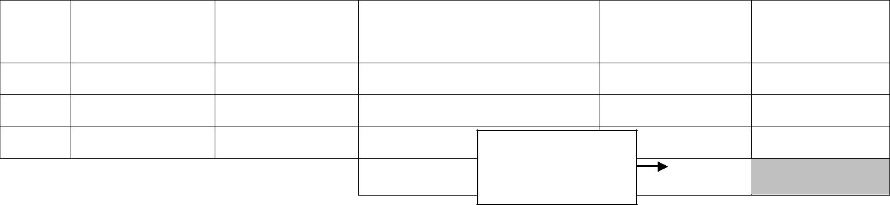
S. | Tax Invoice | Tax Invoice | Supplier TIN No. under |  | Purchase Price | Input Tax
No. | date | No. |  | the Act | (Rs.) | (Rs.)
 |  |  |  | Carry to (7)(i)
 |  |  | Total | of part-A

  - Annex separate sheet if necessary

- Details of packaging material on which credit has been sought
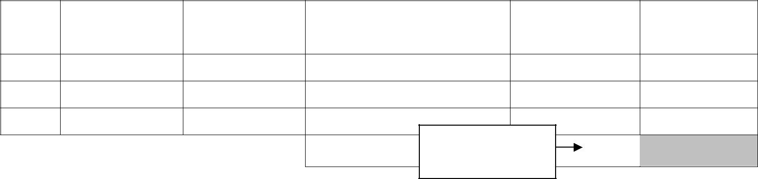
S. | Tax Invoice | Tax Invoice | Supplier Registration No. |  | Purchase Price | Input Tax
No. | date | No. |  | under the Act | (Rs.) | (Rs.)
 |  |  | Total | Carry to (7)(ii)
 |  |  | Total | of part-A
* Annex separate sheet if necessary

Name and signature of applicant / authorized signatory

(iii) Verification

I/We ______________________________________________ hereby solemnly affirm and declare that the information given hereinabove is true and correct to the best of my/our knowledge and belief and nothing has been concealed therefrom.

Signature of Authorised Signatory | ____________________________________
Full Name (first name, middle, surname) | ____________________________________
Designation | ____________________________________

Place

Date

Day | Month | Year

