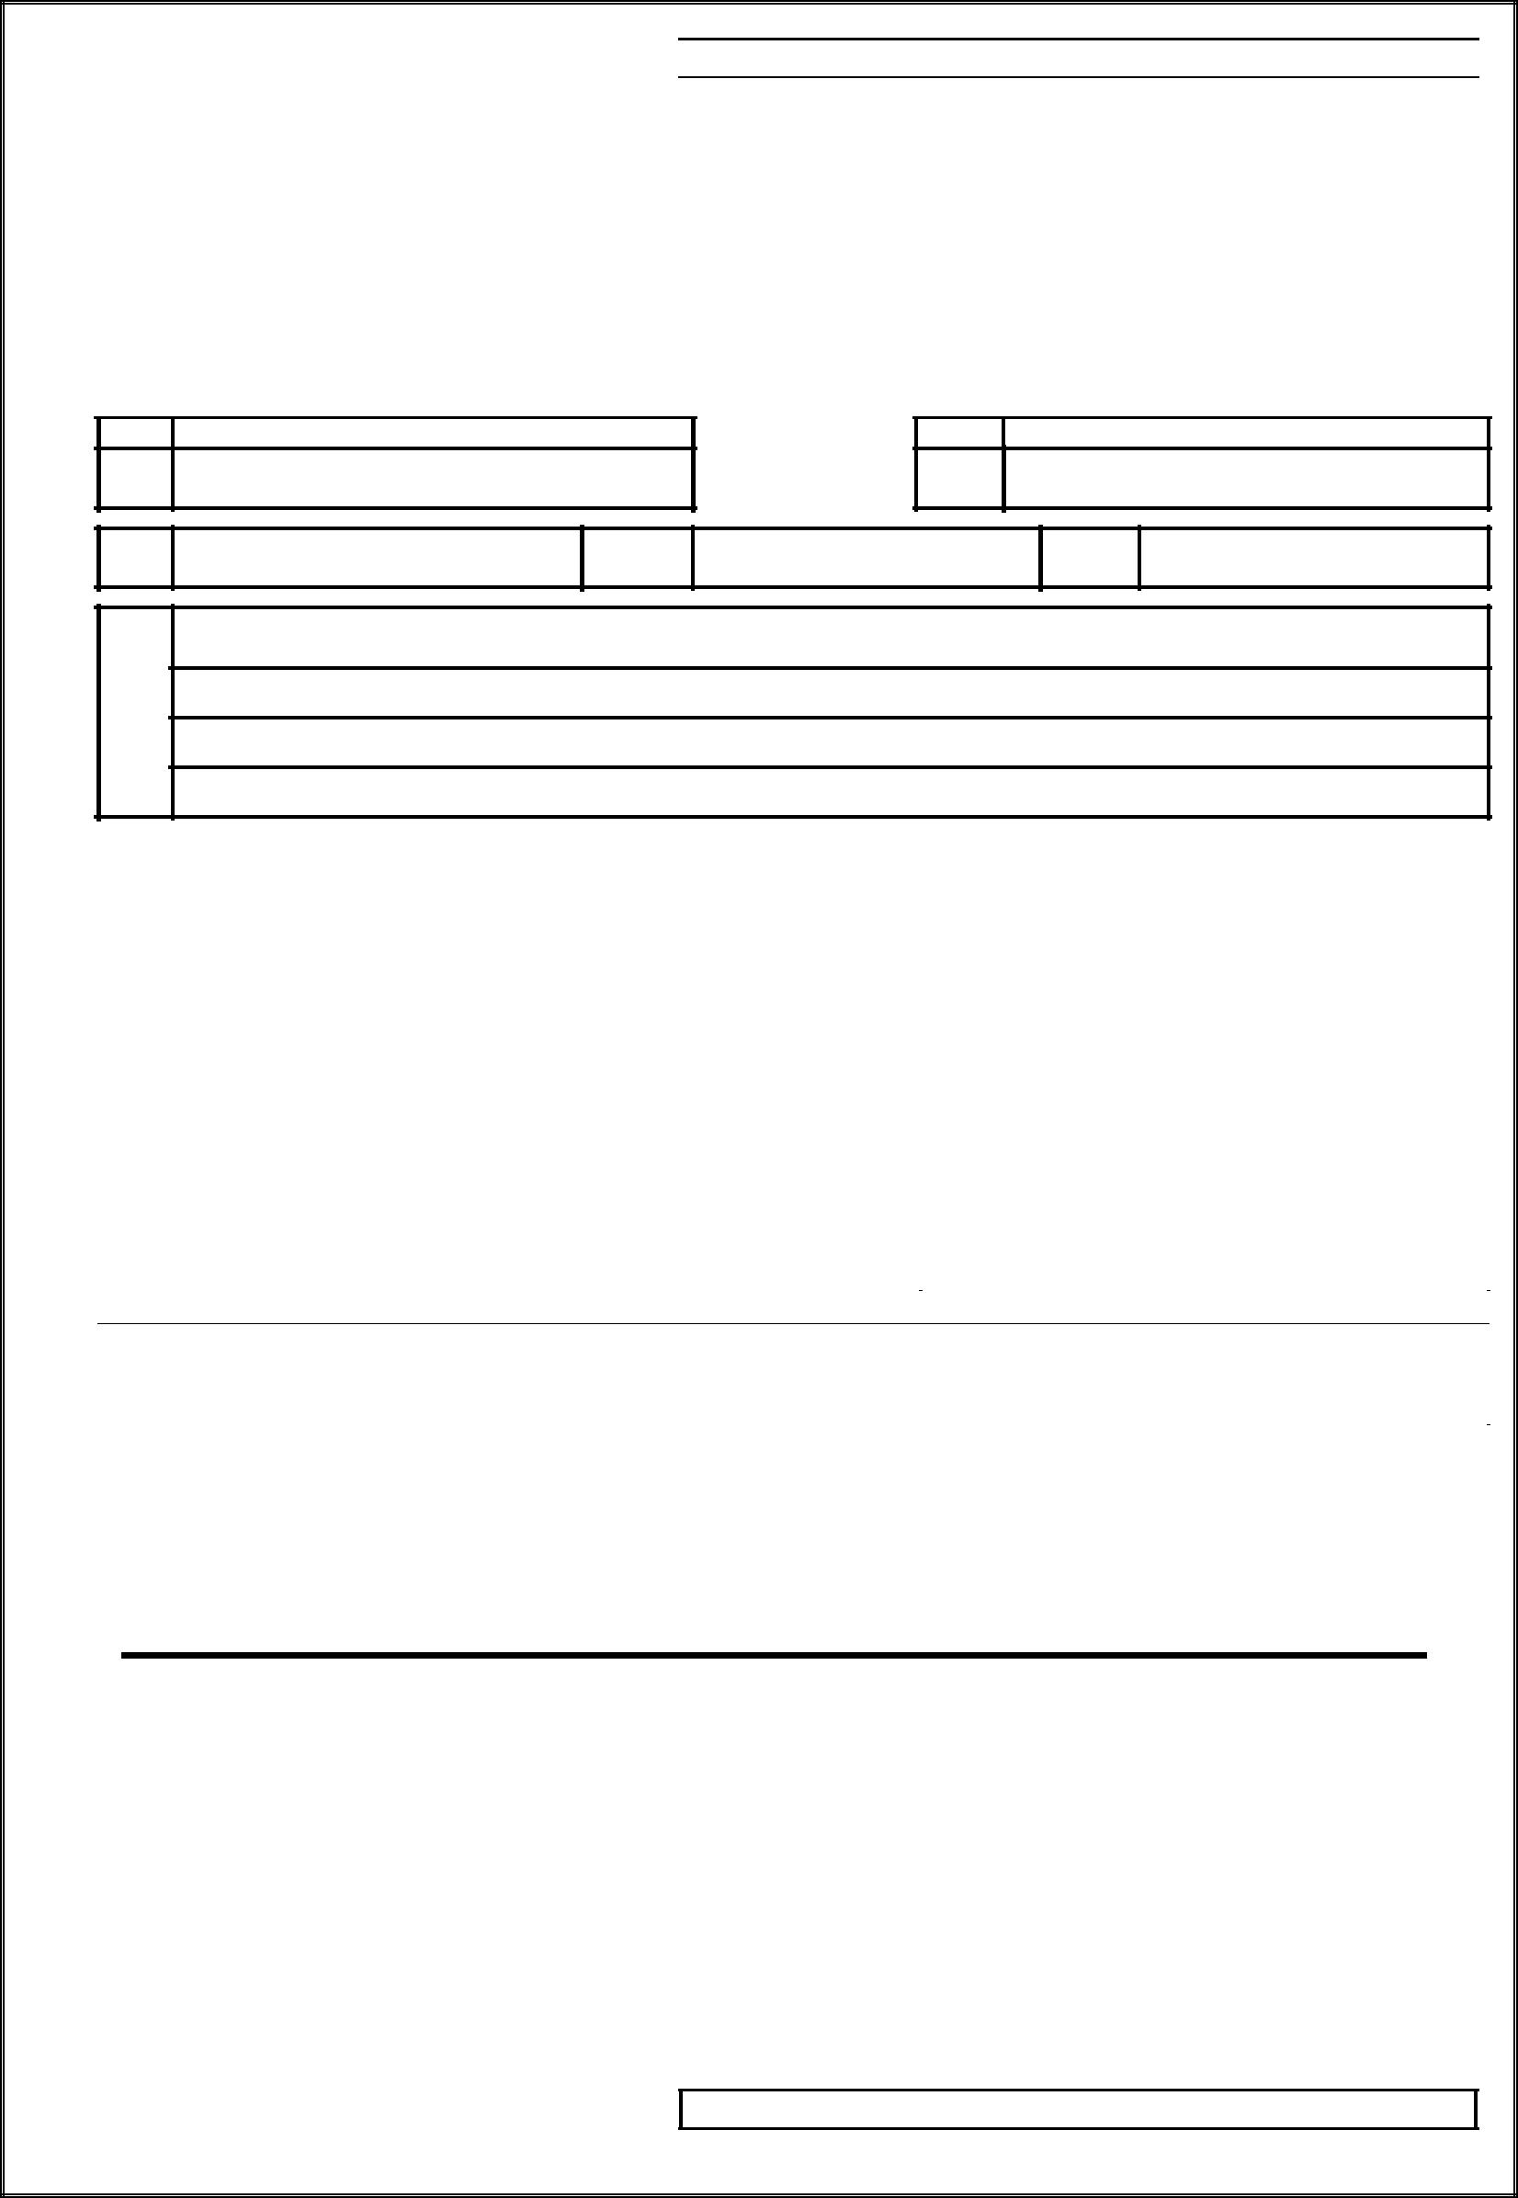
MVAT PAYMENT OTHER THAN WITH RETURN

For the Payer Original FORM 210

( See rule 45 )

Chalan in respect of payment made otherwise than with return by a dealer under Maharashtra Value Added Tax.Act 2002

[0040-Sales Tax Receipts under the MVAT Act, 2002 – Tax Collection] [For Tax payment through Treasury / Bank ]

1) | M.V.A.T. R.C. No, if any | 2) | C.S.T.R.C.No
3) | Period | From | To
4) | Name and address of the person or dealer | on whose behalf money is paid

 | Payment on account of |  | Amount ( in figure) Rs |  |  | Chalan of tax, penalty and composition money
 | (a) Sales Tax |  |  |  |  | paid to the ………………………………………
 | (a) Sales Tax |  |  |  |  | Treasury/ Sub- Treasury …………………………
 | (b) composition under section 42 |  |  |  |  | Reserve Bank of India.
 | (c) Interest under section
 | (d) Penalty under section
 | (e)Composition Money amount for
 | compounding of offence
 | (f) Fine under section 12 (2) or 14(3)
 | (g) Fees payable under rule 73
 | (h) Amount forfeited
 |  | Total Rs
 | Amount in Words
 | Crore | Lac | Thousand | Hundred |  |  | Tens | Units

Date: ________________________ | Signature of Dealer or Depositor | ________________________
Place:._____________________ | Designation | ________________________

For Treasury use only.

Received Rs_______________ In words _______________________________________________________

Date of Entry______________ Chalan No____________ Treasury Accountant / Treasury Officer / Agent / Manager.

MVAT PAYMENT OTHER THAN WITH RETURN

- 1 -

  To be sent to the Sales Tax Officer |  |  |  |  |  |  |  |  |  | Duplicate
 |  |  |  |  | FORM 210
 |  |  |  |  | ( See rule | 45 )
 |  | Chalan in respect of payment made otherwise than with return by a dealer under Maharashtra Value Added
 |  |  |  |  | Tax.Act 2002
 |  | [0040-Sales Tax Receipts under the MVAT Act, 2002 – Tax Collection]
 |  | [ For Tax payment through Treasury / Bank ]
 | 1) | M.V.A.T. R.C. No, if any |  |  |  |  | 2) | C.S.T.R.C.No
 | 3) | Period |  | From |  |  |  |  | To
 | 4) | Name and address of the person or dealer |  | on whose behalf money is paid

 | Payment on account of |  | Amount ( in figure) Rs |  |  | Chalan of tax, penalty and composition money
 | (a) Sales Tax |  |  |  |  | paid to the ………………………………………
 | (a) Sales Tax |  |  |  |  | Treasury/ Sub- Treasury …………………………
 | (b) composition under section 42 |  |  |  |  | Reserve Bank of India.
 | (c) Interest under section
 | (d) Penalty under section
 | (e)Composition Money amount for
 | compounding of offence
 | (f) Fine under section 12 (2) or 14(3)
 | (g) Fees payable under rule 73
 | (h) Amount forfeited
 |  | Total Rs
 | Amount in Words
 | Crore | Lac | Thousand | Hundred |  |  | Tens | Units

Date: ________________________ | Signature of Dealer or Depositor | ________________________
Place:._____________________ | Designation | ________________________

For Treasury use only.

Received Rs_______________ In words _______________________________________________________

Date of Entry______________ Chalan No____________ Treasury Accountant / Treasury Officer / Agent / Manager.

MVAT PAYMENT OTHER THAN WITH RETURN

- 2 -

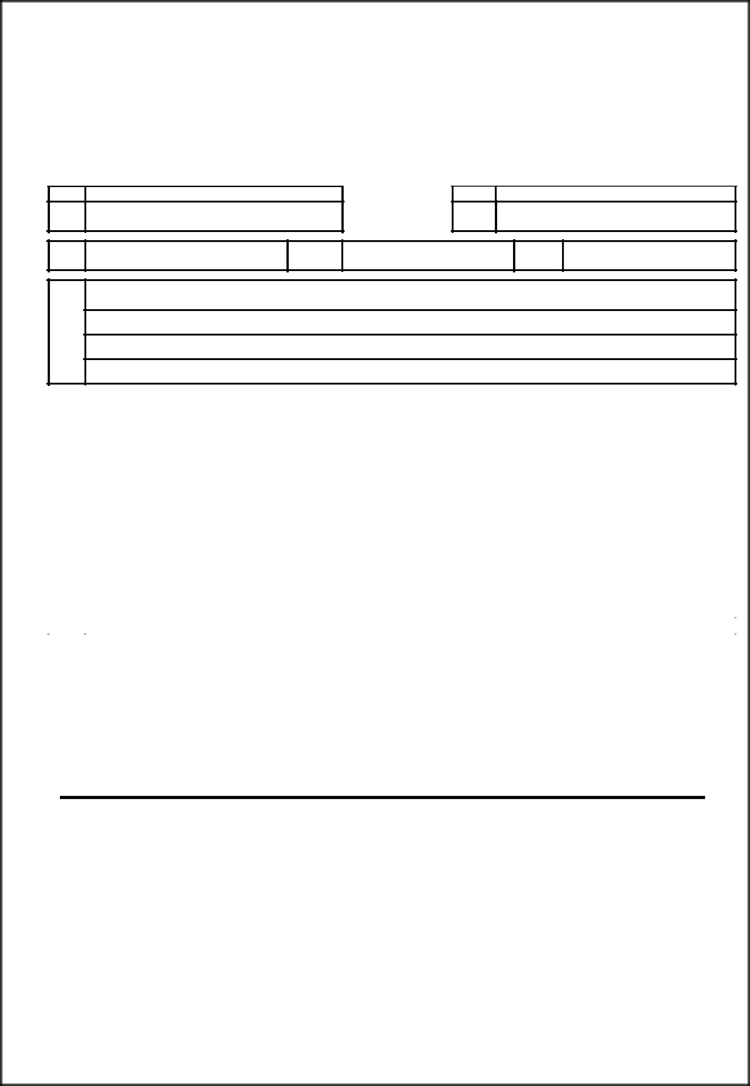  For the Treasury | Triplicate
 | FORM 210
 | ( See rule 45 )
Chalan in respect of payment made otherwise than with return by a dealer under Maharashtra Value Added
 | Tax.Act 2002

[0040-Sales Tax Receipts under the MVAT Act, 2002 – Tax Collection] [For Tax payment through Treasury / Bank ]

1) | M.V.A.T. R.C., if any | 2) | C.S.T.R.C.No
3) | Period | From | To
4) | Name and address of the person or dealer | on whose behalf money is paid

 | Payment on account of |  | Amount ( in figure) Rs |  |  | Chalan of tax, penalty and composition money
 | (a) Sales Tax |  |  |  |  | paid to the ………………………………………
 | (a) Sales Tax |  |  |  |  | Treasury/ Sub- Treasury …………………………
 | (b) composition under section 42 |  |  |  |  | Reserve Bank of India.
 | (c) Interest under section
 | (d) Penalty under section
 | (e)Composition Money amount for
 | compounding of offence
 | (f) Fine under section 12 (2) or 14(3)
 | (g) Fees payable under rule 73
 | (h) Amount forfeited
 |  | Total Rs
 | Amount in Words
 | Crore | Lac | Thousand | Hundred |  |  | Tens | Units

Date: ________________________ | Signature of Dealer or Depositor | ________________________
Place:._____________________ | Designation | ________________________

For Treasury use only.

Received Rs_______________ In words _______________________________________________________

Date of Entry______________ Chalan No____________ Treasury Accountant / Treasury Officer / Agent / Manager.

- 3 -

